Security Vetting form for non-citizen applicant

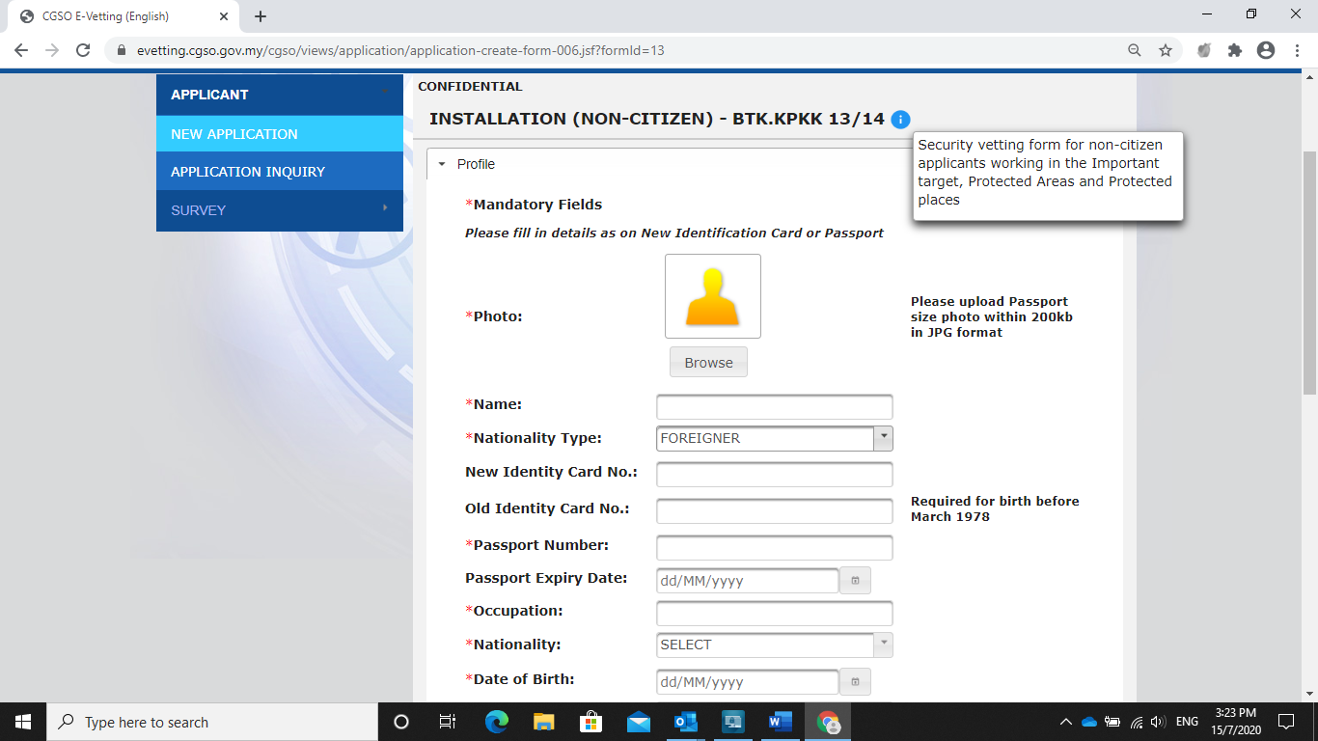

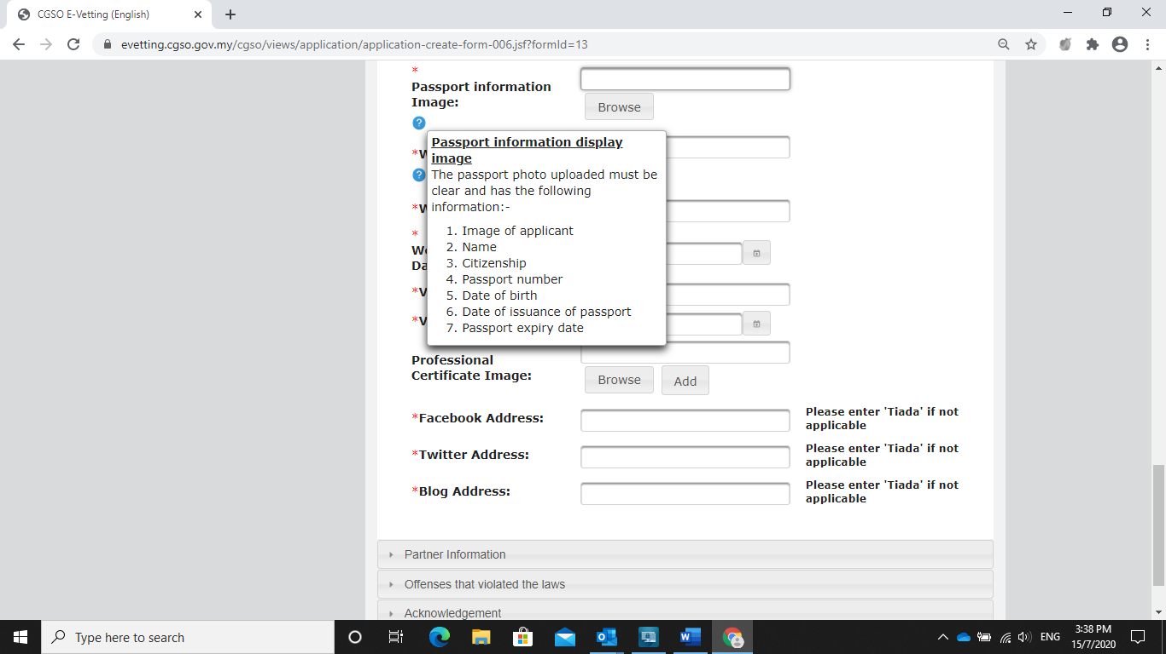

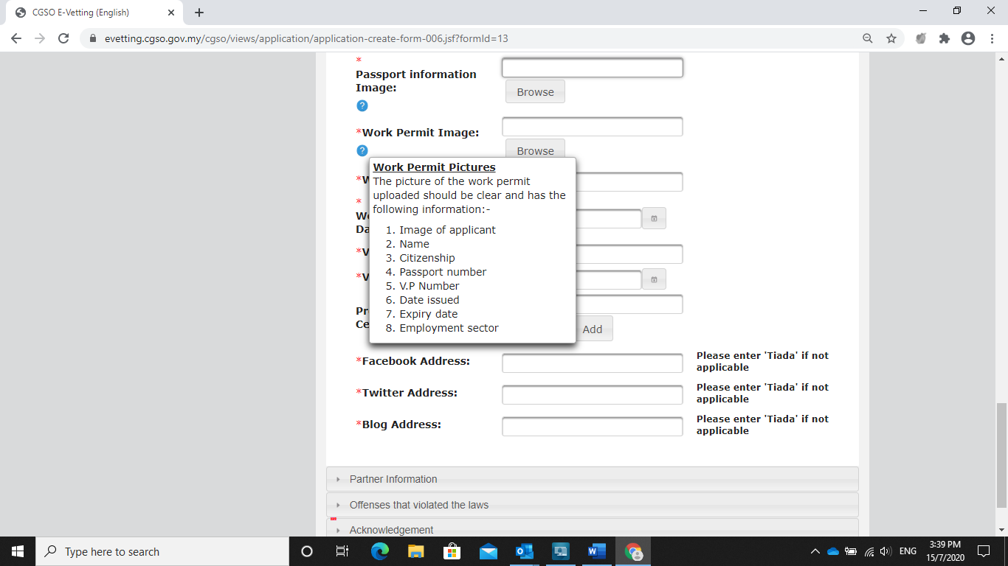

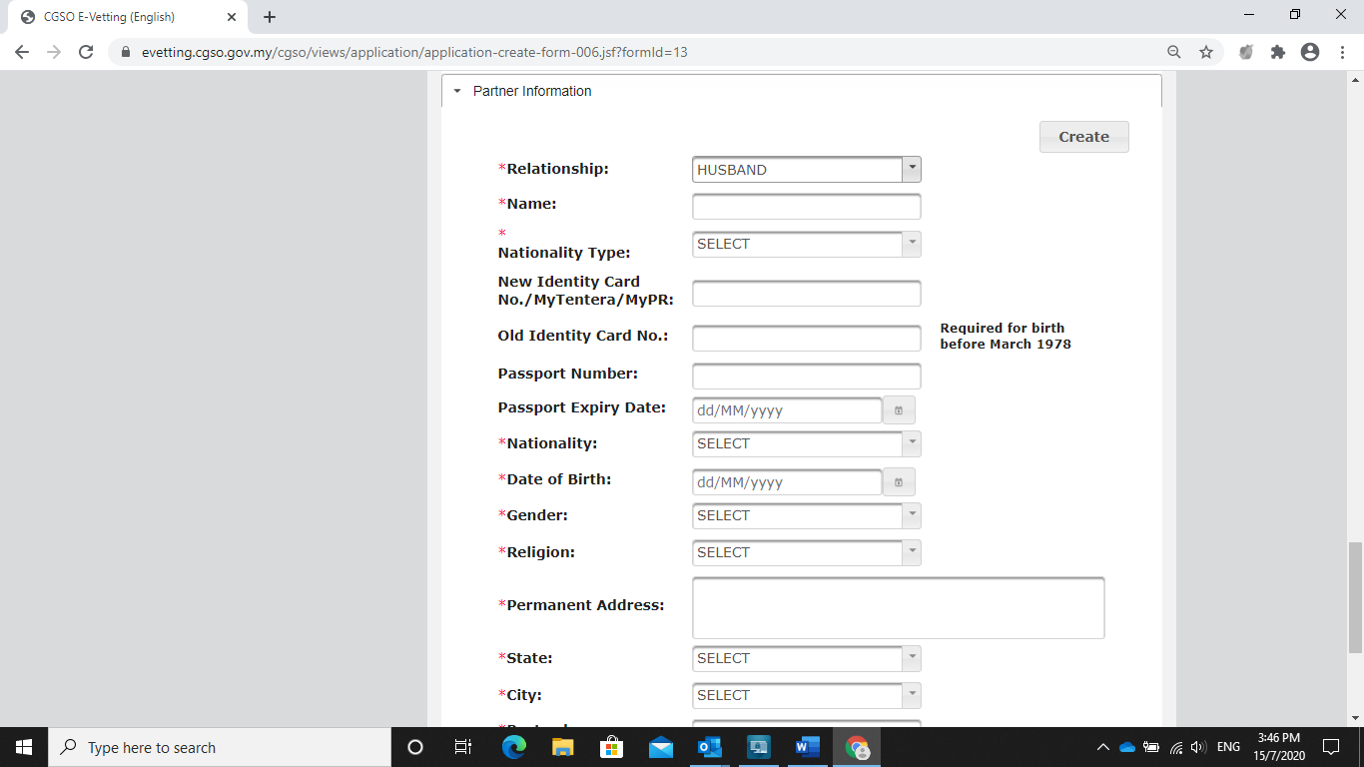



|  |  |  |
| --- | --- | --- |
| **No.** | **Mandatory Fields** |  |
| 1 | Name: | Mujeeba Zainab Khan |
| 2 | Nationality Type: | Resident Indian |
| 3 | Passport Number: | S7130183 |
| 4 | Passport Expiry Date: | 13/09/2028 |
| 5 | Occupation: | Developer/Consultant |
| 6 | Nationality: | Indian |
| 7 | Date of Birth: | 02/12/1996 |
| 8 | Place of Birth: | Burhanpur, Madhya Pradesh, India |
| 9 | Gender: | Female |
| 10 | Religion: | Islam |
| 11 | Permanent Address:  (As on Identification Card) | 151, Parshav kunj, Ahmed nagar, Khajarana near Karnataka School, Kanadia bypass, Indore, Madhya Pradesh, India - 452016 |
| 12 | State: | Madhya Pradesh |
| 13 | City: | Indore |
| 14 | Postcode: | 452016 |
| 15 | Postal Address: | 151, Parshav kunj, Ahmed nagar, Khajarana near Karnataka School, Kanadia bypass, Indore, Madhya Pradesh, India - 452016 |
| 16 | State: | Madhya Pradesh |
| 17 | City: | Indore |
| 18 | Postcode: | 452016 |
| 19 | Marital Status: | Single |
| 20 | Mobile Phone No.: | +91- 9752336615 |
| 21 | Email: | ext_mujeebazainab.khan@malaysiaairlines.com |
| 22 | Workplace Address: | YASH Technologies Pvt. Ltd., Indore-Crystal IT Park-DC (102) Indore, Madhya Pradesh - 452001 |
| 23 | State: | Madhya Pradesh |
| 24 | City: | Indore |
| 25 | Postcode: | 452001 |
| 26 | Passport information image |  |
| 27 | Working Permit image | NA |
| 28 | Work Permit No.: | NA |
| 29 | Work Permit Expiry Date: | NA |
| 30 | Visa No.: | NA |
| 31 | Visa Expiry Date: | NA |
| 32 | Facebook Address: | NA |
| 33 | Twitter Address: | NA |
| 34 | Blog Address: | NA |
| 35 | Relationship: | NA |
| 36 | Name : | NA |
| 37 | Nationality Type: | NA |
| 38 | Passport Number: | NA |
| 39 | Passport Expiry Date: | NA |
| 40 | Nationality: | NA |
| 41 | Date of Birth: | NA |
| 42 | Gander: | NA |
| 43 | Religion: | NA |
| 44 | Permanent Address: | NA |
| 45 | State: | NA |
| 46 | City | NA |
| 47 | Postcode: | NA |
| 48 | Mobile Phone No.: | NA |
| 49 | Occupation: | NA |
| 50 | Offense : | None |
|  |  | I, on behalf of the applicant understands that any false statements or willfully omitted evidence by the applicant may result in the applicant's ineligibility to serve in the Ministry/Department/Agency and legal action based on the current laws in force may be taken.  This Declaration is made on the date : 11/04/2022 |